### Chapter-1

# INTRODUCTION

### 1.1 Data Science:

Data science is an interdisciplinary field that involves using scientific methods, algorithms, and systems to extract knowledge and insights from structured and unstructured data. It combines elements of statistics, computer science, and domain-specific expertise to analyze and interpret complex data sets. Key components of data science include data collection, data cleaning, exploratory data analysis, modeling, and deployment. The primary goal of data science is to uncover patterns and insights that can inform decision-making and drive innovation.

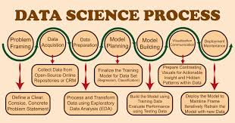

**Fig1: Data Science process**

### 1.2 Key Components of Data Science

1. **Data Collection**: Gathering data from various sources such as databases, web scraping, sensors, and APIs.
2. **Data Cleaning and Preparation**: Processing raw data to handle missing values, outliers, and inconsistencies.
3. **Exploratory Data Analysis (EDA)**: Using statistical techniques and data visualization to understand the data and uncover patterns.
4. **Modeling and Algorithm Development**: Building and training models using machine learning and statistical methods to make predictions or classifications.
5. **Evaluation and Interpretation**: Assessing model performance using appropriate metrics and interpreting the results to gain actionable insights.
6. **Deployment and Monitoring**: Implementing the models in real-world applications and continuously monitoring their performance for improvements.

### 1.3 Applications of Data Science

1. **Healthcare**:
   * **Predictive Modeling**: Forecasting disease outbreaks and patient outcomes.
   * **Personalized Medicine**: Tailoring treatments based on individual patient data.
   * **Medical Imaging**: Analyzing medical images for diagnosis and treatment planning.
2. **Finance**:
   * **Fraud Detection**: Identifying fraudulent transactions and activities.
   * **Risk Management**: Assessing and managing financial risks.
   * **Algorithmic Trading**: Using data-driven algorithms for trading decisions.
3. **Marketing**:
   * **Customer Segmentation**: Grouping customers based on behavior and preferences.
   * **Sentiment Analysis**: Analyzing customer feedback and social media posts.
   * **Recommendation Systems**: Providing personalized product and content recommendations.
4. **Retail**:
   * **Inventory Management**: Optimizing stock levels based on demand forecasts.
   * **Demand Forecasting**: Predicting future sales to manage supply chain.
   * **Personalized Shopping**: Enhancing customer experience with personalized offers.
5. **Transportation**:
   * **Route Optimization**: Finding the most efficient routes for delivery and travel.
   * **Predictive Maintenance**: Anticipating and preventing vehicle breakdowns.
   * **Autonomous Vehicles**: Developing self-driving car technology.
6. **Entertainment**:
   * **Content Recommendation**: Suggesting movies, music, and shows based on user preferences.
   * **Audience Analytics**: Understanding viewer habits and preferences.
   * **Social Media Analysis**: Monitoring trends and sentiments on social platforms.

### 1.4 Impact and Future Directions

Data science has significantly transformed various industries by enabling data-driven decision-making and fostering innovation. The integration of artificial intelligence and machine learning has further expanded its capabilities, making data science a fundamental aspect of modern technology and business strategies. Future advancements are expected in areas such as real-time analytics, ethical AI, and the integration of quantum computing, promising even more profound impacts on how we understand and utilize data.

Data science is a broad and interdisciplinary field that encompasses various techniques and tools to extract knowledge and insights from data. Its scope includes the following areas:

1. **Machine Learning and Artificial Intelligence**:
   * **Supervised Learning**: Algorithms for classification and regression tasks.
   * **Unsupervised Learning**: Clustering and dimensionality reduction techniques.
   * **Reinforcement Learning**: Learning through interaction with an environment to maximize cumulative rewards.
   * **Deep Learning**: Neural networks, particularly for image and speech recognition.
2. **Big Data Technologies**:
   * **Data Storage and Management**: Using databases like SQL, NoSQL, and Hadoop for handling large datasets.
   * **Data Processing**: Tools like Spark and Flink for distributed processing of big data.
   * **Cloud Computing**: Utilizing cloud services for scalable data storage and computing power.
3. **Statistical Analysis**:
   * **Descriptive Statistics**: Summarizing data using measures such as mean, median, and standard deviation.
   * **Inferential Statistics**: Drawing conclusions from data samples through hypothesis testing, confidence intervals, and regression analysis.
4. **Natural Language Processing (NLP)**:
   * **Text Analysis**: Techniques for sentiment analysis, topic modeling, and entity recognition.
   * **Language Generation**: Developing systems for machine translation and text generation.
5. **Data Engineering**:
   * **ETL Processes**: Extracting, transforming, and loading data into data warehouses.
   * **Data Pipelines**: Automating data workflows to ensure continuous data processing.
6. **Domain-Specific Applications**:
   * **Healthcare**: Predictive analytics for patient outcomes, genomics, and medical image analysis.
   * **Finance**: Algorithmic trading, fraud detection, and risk management.
   * **Marketing**: Customer segmentation, campaign optimization, and personalization.

### 1.5 Scope of Data Analysis and Visualization

Data analysis and visualization are critical components of data science, focusing on interpreting data and communicating insights. Their scope includes:

1. **Data Analysis**:
   * **Exploratory Data Analysis (EDA)**: Using statistical methods and visualization tools to understand data distributions, relationships, and patterns.
   * **Descriptive Analysis**: Summarizing historical data to understand what has happened.
   * **Diagnostic Analysis**: Investigating data to understand why something happened.
   * **Predictive Analysis**: Using statistical and machine learning models to predict future trends and outcomes.
   * **Prescriptive Analysis**: Providing recommendations for action based on data insights.
2. **Data Visualization**:
   * **Charting and Graphing**: Creating visual representations such as bar charts, line charts, scatter plots, and histograms to present data.
   * **Interactive Dashboards**: Using tools like Tableau, Power BI, and Plotly to create interactive and dynamic visualizations.
   * **Geospatial Visualization**: Mapping data to geographic locations using tools like GIS and Leaflet.
   * **Infographics**: Designing visual content to communicate complex data in an easily understandable format.
3. **Visualization Tools and Libraries**:
   * **Matplotlib and Seaborn**: Python libraries for static, animated, and interactive visualizations.
   * **D3.js**: A JavaScript library for producing dynamic, interactive data visualizations in web browsers.
   * **ggplot2**: An R package for creating elegant and complex visualizations.
4. **Storytelling with Data**:
   * **Narrative Techniques**: Crafting a compelling story around data insights to engage and inform stakeholders.
   * **Design Principles**: Applying principles of design to create clear, concise, and aesthetically pleasing visualizations.
   * **Interactive Reports**: Developing reports that allow users to interact with data through filters, drill-downs, and other interactive elements.

### 1.6 Integration and Future Directions

The integration of data science with data analysis and visualization provides powerful tools for making data-driven decisions. The future of these fields is likely to see advancements in areas such as real-time data analytics, augmented analytics (using AI to enhance human analysis), and more sophisticated visualization techniques. These advancements will further enable organizations to harness the full potential of their data, driving innovation and efficiency across various sectors.

### Chapter-2

**Web Scraping**

### 

**Fig2: process of web scraping**

Web scraping is a method used to extract data from websites. This technique involves programmatically collecting information from the web and converting unstructured data on a webpage into structured data that can be easily analyzed and used for various applications. Here’s an overview of web scraping, particularly focusing on its implementation using Python:

### 2.1 Key Components of Web Scraping

1. **Understanding the Website Structure**: Analyzing the HTML structure of the target website to identify the elements containing the desired data.
2. **HTTP Requests**: Sending requests to the web server to retrieve the webpage's HTML content.
3. **HTML Parsing**: Parsing the retrieved HTML content to locate and extract the required data.
4. **Data Storage**: Saving the extracted data in a structured format, such as CSV, JSON, or a database.

### 2.2 Tools and Libraries for Web Scraping in Python

1. **Requests**: A library to send HTTP requests and receive responses from web servers.
2. **BeautifulSoup**: A library for parsing HTML and XML documents to extract data.
3. **Selenium**: A library to automate web browsers, useful for scraping dynamic content that requires JavaScript execution
4. **Scrapy**: A powerful and flexible web scraping framework for large-scale data extraction.

### 2.3 Steps in Web Scraping

1. **Sending HTTP Requests**:
   * Use the requests library to send a GET request to the website's URL.

Python code:

import requests

response = requests.get('https://example.com')

html_content = response.content

1. **Parsing HTML Content**:
   * Use BeautifulSoup to parse the HTML content and locate the desired data elements.

Python code:

from bs4 import BeautifulSoup

soup = BeautifulSoup(html_content, 'html.parser')

data_elements = soup.find_all('tag', class_='class_name')

1. **Extracting Data**:
   * Loop through the parsed elements and extract the required information.

Python code:

extracted_data = []

for element in data_elements:

data = element.text

extracted_data.append(data)

1. **Handling Dynamic Content**:
   * Use Selenium to handle websites that load content dynamically with JavaScript.

Python code:

from selenium import webdriver

driver = webdriver.Chrome()

driver.get('https://example.com')

html_content = driver.page_source

soup = BeautifulSoup(html_content, 'html.parser')

driver.quit()

1. **Storing Data**:
   * Save the extracted data into a structured format such as CSV.

Python code:

import csv

with open('data.csv', 'w', newline='') as file:

writer = csv.writer(file)

writer.writerow(['Header1', 'Header2'])

for data in extracted_data:

writer.writerow([data])

### 2.4 Ethical Considerations

1. **Respect Website Policies**:
   * Adhere to the website's robots.txt file to understand what parts of the site can be scraped.
   * Respect the website's terms of service.
2. **Minimize Impact**:
   * Implement rate limiting to avoid overwhelming the web server with requests.
   * Use polite scraping techniques, such as identifying your scraper with a user agent string.
3. **Legal Compliance**:
   * Ensure that the data scraping activity complies with relevant legal regulations and copyright laws.

### 2.5 Applications of Web Scraping

1. **Price Comparison**:
   * Extract product prices from different e-commerce websites to create price comparison tools.
2. **Market Research**:
   * Gather data on competitors, market trends, and customer reviews.
3. **Sentiment Analysis**:
   * Scrape social media sites and forums to analyze public sentiment on various topics.
4. **Content Aggregation**:
   * Collect news articles, blog posts, and other content from multiple sources into a single platform.
5. **Academic Research**:
   * Extract large datasets for research purposes in fields such as economics, sociology, and data science.

Web scraping is a powerful technique for data extraction and has a wide range of applications. Python, with its rich set of libraries and tools, makes web scraping accessible and efficient. However, it is essential to conduct web scraping ethically and legally to respect the rights of website owners and comply with regulations.

### Chapter-3

**Data Analysis & Visualization**

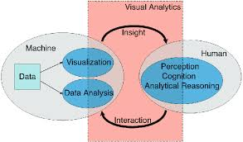

**Fig 3: visual analysis**

#### **3.1 Steps in Data Analysis**

**Data Cleaning**:

Data cleaning, also known as data cleansing or data wrangling, is a crucial process in data preprocessing that involves identifying and correcting (or removing) errors and inconsistencies in data to improve its quality. This step is essential before conducting any data analysis, machine learning, or business intelligence tasks. Below is a brief overview of the main components and steps involved in data cleaning:

#### 1. **Data Collection and Initial Review**

* **Data Sources:** Identify and gather data from various sources (databases, files, APIs).
* **Initial Inspection:** Review the structure, format, and content of the data to understand its characteristics and potential issues.

#### 2. **Handling Missing Data**

* **Identify Missing Data:** Detect missing values in the dataset.
* **Imputation:** Fill missing values using methods such as mean, median, mode, or more sophisticated techniques like regression or K-nearest neighbors.
* **Removal:** Remove records or variables with a high percentage of missing data, if imputation is not feasible.

#### 3. **Data Standardization and Normalization**

* **Standardization:** Convert data into a common format. For example, date formats, text cases, and categorical variable encoding.
* **Normalization:** Scale numerical values to a standard range (e.g., 0-1) to ensure consistency and comparability.

#### 4. **Outlier Detection and Treatment**

* **Identify Outliers:** Use statistical methods (e.g., Z-score, IQR) or visualization techniques (e.g., box plots) to detect outliers.
* **Treatment:** Depending on the context, outliers can be removed, transformed, or investigated further to understand their impact.

#### 5. **Handling Duplicates**

* **Detection:** Identify duplicate records in the dataset.
* **Removal:** Remove exact duplicates or use more sophisticated methods for near-duplicates, ensuring that important information is not lost.

#### 6. **Addressing Inconsistencies**

* **Consistency Checks:** Ensure that data values follow business rules or constraints (e.g., age should be a positive number, dates should be valid).
* **Correction:** Correct inconsistent data based on predefined rules or external references.

#### 7. **Data Transformation**

* **Deriving New Features:** Create new variables from existing ones to provide more meaningful insights.
* **Encoding Categorical Variables:** Convert categorical data into numerical format using methods like one-hot encoding or label encoding.

#### 8. **Data Integration**

* **Merging Data:** Combine data from different sources, ensuring consistency and resolving conflicts.
* **Linking Data:** Match records from different datasets based on common identifiers.

#### 9. **Validation and Verification**

* **Validation:** Ensure that the cleaned data meets the desired quality standards and is suitable for analysis.
* **Verification:** Cross-check cleaned data with original sources or use sample validation to ensure accuracy.

#### 10. **Documentation**

* **Document Process:** Keep detailed records of all cleaning steps, assumptions made, and decisions taken to ensure reproducibility and transparency.
* **Create Data Dictionary:** Update the data dictionary to reflect changes and provide clear metadata for future users.

### 3.1.1 Tools and Techniques

* **Programming Languages:** Python (pandas, NumPy), R
* **Data Cleaning Software:** OpenRefine, Talend, Trifacta
* **Databases:** SQL for data manipulation and querying

### 3.1.2 Best Practices

* **Iterative Process:** Data cleaning is iterative; continually refine and improve data quality.
* **Automation:** Use scripts and automation to handle repetitive tasks.
* **Collaboration:** Work with domain experts to understand the data context and ensure accurate cleaning.
* **Monitoring:** Continuously monitor data quality to detect and address issues promptly.

Data cleaning is a foundational step in any data-related project, ensuring that subsequent analysis is based on accurate, reliable, and high-quality data.

1. **Exploratory Data Analysis (EDA)**:
   * Use statistical methods and visualization tools to understand data distributions and relationships.
2. **Statistical Analysis**:
   * Apply descriptive and inferential statistics to analyze data.
3. **Machine Learning**:
   * Build predictive models to make forecasts or classifications.

### 3.2 Data Visualization

**Data visualization** is the process of presenting data in graphical formats to make it easier to understand and communicate insights.

Data visualization is the graphical representation of information and data. By using visual elements like charts, graphs, and maps, data visualization tools provide an accessible way to see and understand trends, outliers, and patterns in data. It plays a crucial role in data analysis, enabling stakeholders to make informed decisions.

#### **3.2.1 Importance of Data Visualization**

1. **Simplifies Complex Data:** Converts large and complex datasets into visual representations that are easier to understand.
2. **Reveals Insights:** Helps in identifying trends, patterns, and correlations that might not be evident in raw data.
3. **Enhances Communication:** Visuals make it easier to communicate findings to a non-technical audience.
4. **Supports Decision Making:** Provides a clear and immediate understanding of the data, aiding in faster and more accurate decision-making.

#### **3.2.2 Types of Data Visualizations**

1. **Univariate Visualizations:**
   * **Histogram:** Displays the distribution of a single numerical variable.
   * **Box Plot:** Shows the distribution of a numerical variable and identifies outliers.
   * **Bar Chart:** Represents categorical data with rectangular bars.
2. **Bivariate Visualizations:**
   * **Scatter Plot:** Examines the relationship between two numerical variables.
   * **Line Chart:** Displays data points in a time series, showing trends over time.
   * **Heatmap:** Uses color to represent the magnitude of values, useful for showing correlations.
3. **Multivariate Visualizations:**
   * **Pair Plot:** Displays scatter plots for pairs of numerical variables along with their distributions.
   * **Bubble Chart:** A scatter plot where a third variable is represented by the size of the points.
   * **3D Scatter Plot:** Visualizes relationships in three dimensions.
4. **Geospatial Visualizations:**
   * **Choropleth Map:** Uses color shading to represent data values across geographical areas.
   * **Dot Map:** Represents data points on a geographical map.
   * **Heat Map:** Shows the intensity of data at geographic locations using color gradients.
5. **Time Series Visualizations:**
   * **Line Chart:** Tracks changes over short and long periods of time.
   * **Area Chart:** Similar to a line chart but with the area below the line filled in.
   * **Time Series Heatmap:** Displays time-based data in a matrix, with color representing the value.
6. **Categorical Data Visualizations:**
   * **Bar Chart:** Compares categories using rectangular bars.
   * **Pie Chart:** Shows proportions of a whole.
   * **Stacked Bar Chart:** Similar to a bar chart but segments within each bar represent subcategories.
7. **Hierarchical Data Visualizations:**
   * **Tree Map:** Displays hierarchical data as nested rectangles.
   * **Sunburst Chart:** Similar to a pie chart, but shows hierarchical relationships.
   * **Dendrogram:** Represents data in a tree-like structure.

#### **3.2.3 Tools for Data Visualization**

* **Python Libraries:**
  + **Matplotlib:** Comprehensive library for creating static, animated, and interactive visualizations.
  + **Seaborn:** Statistical data visualization built on top of Matplotlib.
  + **Plotly:** Interactive web-based visualizations.
  + **Bokeh:** Interactive visualizations for modern web browsers.
  + **Altair:** Declarative statistical visualization library based on Vega and Vega-Lite.
* **R Packages:**
  + **ggplot2:** Powerful tool for creating complex and customizable plots.
  + **plotly:** Interactive visualizations.
  + **shiny:** Web applications for interactive data visualization.
  + **lattice:** Trellis graphics for R.
* **BI Tools:**
  + **Tableau:** User-friendly data visualization tool that allows for the creation of a wide range of interactive and shareable dashboards.
  + **Power BI:** Business analytics service providing interactive visualizations.
  + **QlikView/Qlik Sense:** Data visualization tools for self-service analytics.
* **Web-Based Tools:**
  + **Google Data Studio:** Free tool for creating interactive dashboards and reports.
  + **D3.js:** JavaScript library for producing dynamic, interactive data visualizations in web browsers.
  + **Highcharts:** Interactive charting library.

#### **3.2.4 Best Practices for Data Visualization**

1. **Know Your Audience:** Tailor visualizations to the needs and expertise of your audience.
2. **Choose the Right Chart Type:** Select a visualization that best represents the data and insights you want to convey.
3. **Keep It Simple:** Avoid clutter and focus on clarity. Too many elements can confuse the viewer.
4. **Use Color Wisely:** Utilize color to highlight key data points and maintain accessibility for color-blind users.
5. **Provide Context:** Include titles, labels, legends, and annotations to make the visualization self-explanatory.
6. **Ensure Accuracy:** Maintain integrity and accuracy in how data is represented. Avoid misleading scales and representations.
7. **Interactive Elements:** Use interactive elements like tooltips, zooming, and filtering to allow deeper exploration of the data.

Data visualization is a powerful tool for understanding and communicating data. By following best practices and utilizing the right tools, you can create effective visualizations that provide valuable insights and support informed decision-making.

## **Chapter 4**

## **Report of Web Scraping on Flipkart.com**

## **4.1 Python code for web scraping**

## from bs4 import BeautifulSoup

## import requests

## import pandas as pd

## import numpy as np

## def get_Product_title(soap):

## try:

## Product_title=new_soap.find("span", attrs={'class':'VU-ZEz'}).text.strip()

## except AttributeError:

## Product_title=''

## return Product_title

## def get_Product_Rating(soap):

## try:

## Product_Rating=new_soap.find("div", attrs={'class':'ipqd2A'}).text.strip()

## except AttributeError:

## Product_Rating=''

## return Product_Rating

## def get_Product_Price(soap):

## try:

## Product_Price=new_soap.find("div", attrs={'class':'Nx9bqj CxhGGd'}).text.strip()

## except AttributeError:

## Product_Price=''

## return Product_Price

## if __name__ == '__main__':

## user_agent='Mozilla/5.0 (Windows NT 10.0; Win64; x64) AppleWebKit/537.36 (KHTML, like Gecko) Chrome/126.0.0.0 Safari/537.36'

## Headers = {

## 'User-Agent': user_agent,

## 'Accept-Language': 'en-us,en;q=0.5'

## }

## #flipkart.com

## url='https://www.flipkart.com/mobile-phones-store'

## web_page=requests.get(url,headers=Headers)

## #soap object containing all data

## soap=BeautifulSoup(web_page.content,'html.parser')

## #fetch links as list of tag object

## links=soap.find_all("a", attrs={'class':'wjcEIp'})

## #store links

## Links_list=[]

## #loops for extracting links from tag Object

## for link in links:

## Links_list.append(link.get('href'))

## d={'title':[],'rating':[],'price':[]}

## #loop for extracting product detailes from each link

## for link in Links_list:

## product_list='https://www.flipkart.com/mobile-phones-store/'+link

## new_webpage=requests.get(product_list,headers=Headers)

## new_soap=BeautifulSoup(new_webpage.content,'html.parser')

## #Fuction calls to display all necessary product information

## d['title'].append(get_Product_title(new_soap))

## d['rating'].append(get_Product_Rating(new_soap))

## d['price'].append(get_Product_Price(new_soap))

## fliplart_df=pd.DataFrame.from_dict(d)

## fliplart_df['title'].replace('',np.nan,inplace=True)

## fliplart_df=fliplart_df.dropna(subset={'title'})

## fliplart_df.to_csv('scraped_data.csv', header=True , index=False)

## **4.2 Python code to analyses scraped data**

## import pandas as pd

## import matplotlib.pyplot as plt

## import numpy as np

## #read csv

## data=pd.read_csv('scraped_data.csv')

## #graph plots

## print(data.head(5))

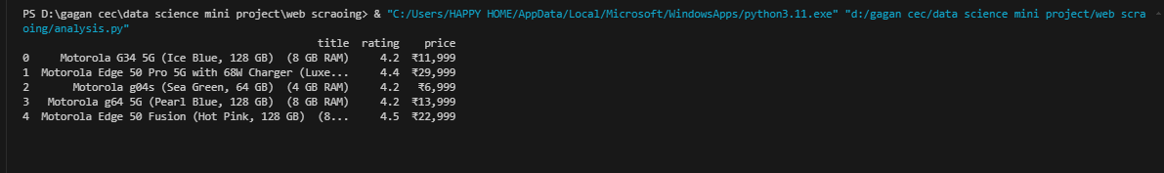

**Fig 4: accessing csv file**

## phone=data['title'].values

## rating=data['rating'].values

## price=data['price'].values

## #print(phone)

## #print(rating)

## #simple plot

## plt.plot(phone,rating,marker="*",color='green',mec='r')

## plt.xlabel('phone')

## plt.ylabel('Rating')

## plt.title('phone Vs Rating')

## plt.show()

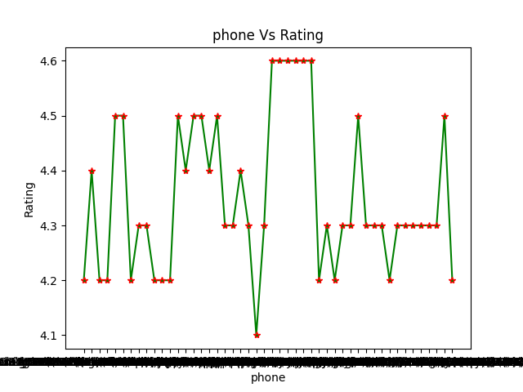

**Fig 5:phone v/s rating plot**

## #horizontal bar graph

## plt.barh(phone,rating,color='red')

## plt.xlabel('phone')

## plt.ylabel('Rating')

## plt.title('phone Vs Rating')

plt.show()

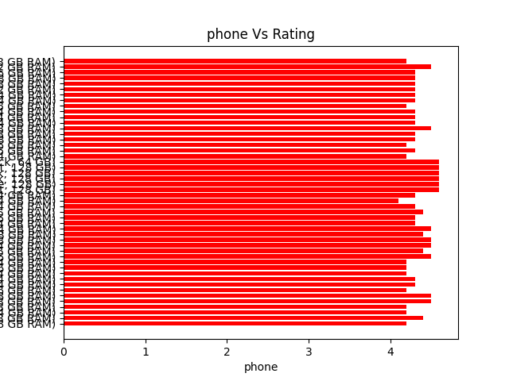

**Fig 6; horizontal bar graph phone v/s rating**

## #simple plot

## plt.plot(rating,price,marker="*",color='pink',mec='green')

## plt.xlabel('Rating')

## plt.ylabel('Price')

## plt.title('Rating Vs Price')

## plt.show()

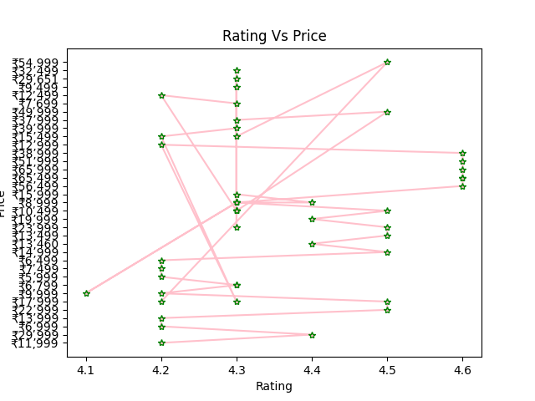

**Fig 7: line plot of rating v/s price**

## #horizontal bar graph

## plt.barh(price,rating,color='green')

## plt.xlabel('Rating')

## plt.ylabel('Price')

## plt.title('Rating Vs Price')

## plt.show()

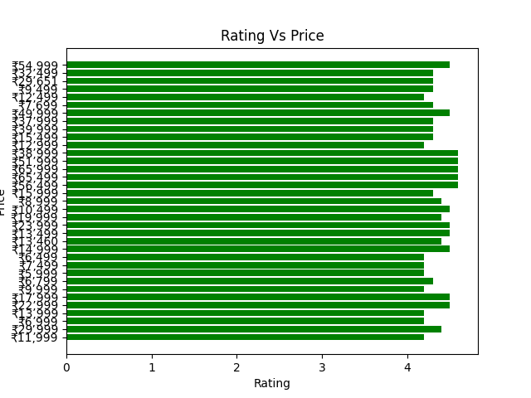

**Fig 8: horizontal bar graph of price v/s rating**

## #simple plot

## plt.plot(phone,price,marker="*",color='blue',mec='orange')

## plt.xlabel('Phone')

## plt.ylabel('Rating')

## plt.title('Phone Vs Rating')

plt.show()

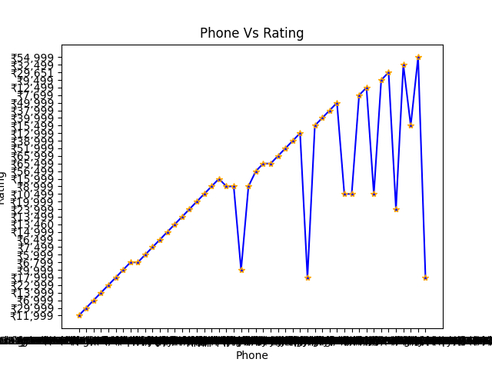

**Fig 9: phone v/s rating trend**

## #horizontal bar graph

## plt.barh(phone,price,color='green')

## plt.xlabel('Phone')

## plt.ylabel('Rating')

## plt.title('Phone Vs Rating')

## plt.show()

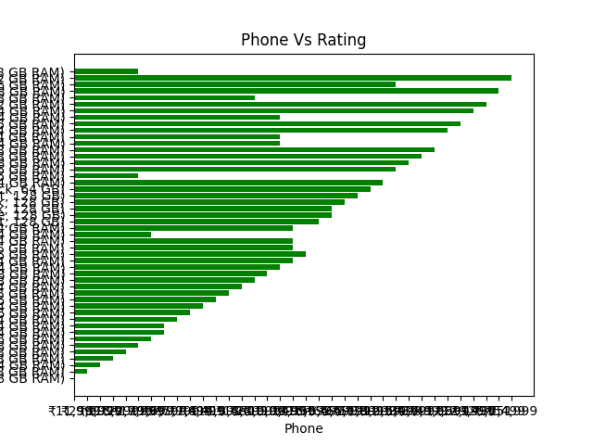

**Fig 10: phone v/s rating trend in horizontal bar graph**

# CONCLUSION

Web scraping on Flipkart, an e-commerce giant, involves extracting product data, reviews, prices, and other relevant information from the website. Here’s a brief conclusion:

### Benefits

1. **Price Monitoring**: Track price changes and trends for products.
2. **Competitive Analysis**: Analyze competitor strategies and product offerings.
3. **Market Research**: Gather data for understanding market demand and customer preferences.
4. **Inventory Management**: Monitor stock levels and product availability.

### Challenges

1. **Legal and Ethical Concerns**: Potential violation of Flipkart’s terms of service and copyright laws.
2. **Anti-Scraping Measures**: Flipkart employs techniques like CAPTCHA, dynamic content, and rate limiting to prevent scraping.
3. **Data Accuracy**: Ensuring the accuracy and relevance of the scraped data can be challenging due to frequent website updates.

### Best Practices

1. **Seek Permission**: Obtain explicit permission from Flipkart to scrape their website.
2. **Respect Website Limits**: Avoid aggressive scraping that may disrupt Flipkart’s services.
3. **Use APIs**: Whenever possible, use Flipkart’s official APIs for data access, ensuring compliance and reducing technical hurdles.

Web scraping on Flipkart can provide valuable insights for price monitoring, competitive analysis, and market research. However, it is essential to navigate legal, ethical, and technical challenges responsibly, potentially leveraging official APIs and adhering to best practices to minimize risks.

## **Future Scope**

The future of web scraping is promising, with advancements in AI, machine learning, and cloud computing paving the way for more sophisticated and efficient data extraction methods. As legal and ethical frameworks evolve, web scraping will continue to be an invaluable tool across various industries, driving innovation and data-driven decision-making.

# REFERENCES

**Books:**

1. "Web Scraping with Python: Collecting More Data from the Modern Web" by Ryan Mitchell
2. "Python Web Scraping Cookbook: Over 90 proven recipes to get you scraping with Python, microservices, Docker, and AWS" by Michael Heydt
3. "Web Scraping with Python: A Step-by-Step Guide to Writing Web Scrapers" by Octoparse Team

# Websites:

1. https://www.geeksforgeeks.org/software-testing-basics/
2. <https://youtube.com>
3. <https://openai.com/chatgpt>
4. https://www.blackbox.ai/